DATE : 15.02.2019
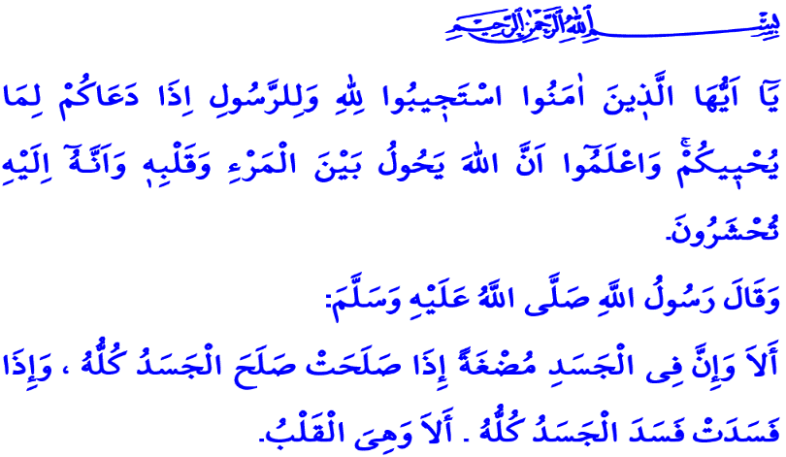THE WAY OF MAKING LIFE LIVABLE: RELIGION AND SPIRITUALITY
Honorable Muslims!
Human beings need love, affection, and company from birth to death. They search for a friend who will treat their spiritual gaps and spiritual tremors throughout his life. Our Lord's mercy is the only support that will give man peace in the world and the Hereafter. Indeed, Almighty Allah is closer to the human beings than their jugular veins. When they pray, He answers them. He never leaves them alone in the misfortunes, equips them with reason, heart, consciousness, and conscience. To the person who thinks that he is helpless, He grants exits in the example of Our Beloved Prophet.
Valuable Believers!
Every period of life is accompanied by its own blessings and burdens. The years of childhood, youth, adulthood and old age sometimes go with beautiful memories, sometimes in distress and sadness. Confronting the examinations we face in life and finding a solution are primarily possible with a sound heart. A sound heart is a heart that finds peace in surrendering to Allah. Believer, nourishes his heart with faith. Keeps his spirituality strong. He takes his energy from worship. The doctor of hearts, Our Beloved Prophet (s.a.w.), described the importance of spirituality that settles in the heart, as follows: “…Beware! There is a piece of flesh in the body if it becomes good (reformed) the whole body becomes good, but if it gets spoilt the whole body gets spoilt, and that is the heart.”
Valuable Muslims!
A person who believes that he is under His unique mercy and protection and that He can see and hear him at any moment does not have fear of being alone and forlorn. He takes power from faith and spirituality to make life livable, to overcome difficulties, to increase goodness. As he feeds his spiritual world in healthy ways, he distances himself from tension and conflict. He will have peace and his hope increases. Because, as our supreme religion teaches us, human beings have spiritual needs as much as material needs. Spirituality is a natural part of life. It is a source of hope, patience and tolerance.
Esteemed Muslims!
Today, although the means of communication increases, human beings are lonelier. Family ties were weakened and kinship relations lost their vitality. The culture of consumption, based on waste and pretentiousness, has brought humanity in terms of the spirit and body, to the brink of extinction. At such a time, spiritual support and guidance for people of all ages is an indispensable need. Moral support; inoculates persistence and perseverance to those in need of help to survive. It spreads mercy by saying stop to violence and persecution. It becomes hope in coping with pain and grief, in getting rid of addiction.
Honorable Believers!
The Supreme Allah, commands in a verse: “O you who have believed, respond to Allah and to the Messenger when he calls you to that which gives you life. And know that Allah intervenes between a man and his heart and that to Him you will be gathered.”
Our clergy, who is now the servants of goodness, is responsible for the task of illuminating the society with the life-giving Islam. They serve the society day and night with sound religious knowledge and deep-rooted experience of our tradition. They give spiritual counseling and guidance to our nation in every aspect of life such as hospitals, penitentiary institutions, nursing homes, health institutions and dormitories especially mosques and Qur'an courses.
Esteemed Believers!
The only salvation that will make life meaningful for the depressed man is to return to its essence, to search for verity and to keep his spirituality alive. Let us not forget that the tired hearts, refresh with faith and fondness. Worn values are repaired with conscience. Sliding lives stabilize with spiritual support and guidance.
I finish my khutbah with the translation of Surah Ash-Sharh, that The Supreme Allah bestowed to Our Beloved Prophet (s.a.w.) and to all humanity as peace of mind: “Did We not expand for you, [O Muhammad], your breast? And We removed from you your burden. Which had weighed upon your back. And raised high for you your repute. For indeed, with hardship [will be] ease. Indeed, with hardship [will be] ease. So when you have finished [your duties], then stand up [for worship]. And to your Lord direct [your] longing.”

Bukhari, Belief, 39.
Al-Anfal, 8/24.
Ash-Sharh, 94/1-8. General Directorate of Religious Services

